**Affiliated to Guru Gobind Singh Indraprastha University**

**SUMMER TRAINING IN AI/ML**



**TEAM NAME: NEURAL NEXUS**

**TEAM MEMBERS**

**Topic: "Personalized Music Recommendation System Using Collaborative Filtering and Content-Based Techniques"**



1. **Dhruv Dhayal 2. Aditya Raj**
2. **Kshitiz Khandelwal 4. Yugansh Gupta**

**Institute of Information Technology & Management**

**"Personalized Music Recommendation System Using Collaborative Filtering and Content-Based Techniques"**

1. **Abstract**

In recent years, music streaming services have experienced exponential growth, with millions of users relying on them for daily music consumption. A key feature that enhances user experience on these platforms is the personalized music recommendation system. This project explores the development of a personalized music recommendation system using collaborative filtering and content-based techniques. Collaborative filtering leverages user behavior to recommend music, while content-based filtering uses metadata and audio features. By integrating these approaches, we aim to create a hybrid system that provides accurate and relevant music recommendations.

The system is built using Python and employs machine learning libraries and frameworks such as scikit-learn, pandas, and NumPy. The datasets used include user listening history and song metadata. The collaborative filtering component predicts user preferences based on the behavior of similar users, while the content-based filtering component recommends items similar to those the user has liked in the past, based on item features.

The project's outcome demonstrates the effectiveness of combining collaborative filtering with content-based techniques to improve recommendation accuracy and user satisfaction. The hybrid approach leverages both user interactions and song attributes, resulting in a more comprehensive and precise recommendation system. This study highlights the potential for hybrid models to enhance personalized recommendations in the music streaming industry.

1. **Introduction**

**2.1 The Field Selected**

The field of music recommendation systems has evolved significantly with the advent of digital music streaming platforms. These systems are designed to suggest songs and playlists to users based on their listening history and preferences. The primary goal is to enhance user experience by providing personalized content, thereby increasing user engagement and satisfaction.

**2.2 Successful Frameworks**

Music recommendation systems utilize various frameworks to achieve personalization. The most successful frameworks include collaborative filtering, content-based filtering, and hybrid approaches. Collaborative filtering predicts user preferences based on the behavior of similar users. Content-based filtering recommends items similar to those the user has liked in the past, using item attributes. Hybrid approaches combine both techniques to leverage the strengths of each method.

**2.3 Relevant Use in Industry**

In the music streaming industry, recommendation systems are integral to the success of platforms like Spotify, Apple Music, and Pandora. These systems help in maintaining user engagement by offering personalized playlists and song recommendations. By analyzing user behavior and preferences, these platforms can provide a more tailored experience, keeping users satisfied and reducing churn rates.

**2.4 How It Will Be Used in the Project**

In this project, we aim to develop a personalized music recommendation system using a hybrid approach that combines collaborative filtering and content-based techniques. The datasets utilized include user listening history and song metadata, obtained from the Spotify API and imported CSV files. The project involves the following steps:

**1. Data Collection:** Gathering user interaction data and song metadata.

**2. Data Exploration:** Analyzing the datasets to understand user behavior and song features.

**3. Feature Engineering:** Creating features for the recommendation system.

**4. Model Building:**

- Collaborative Filtering: Using user interaction data to predict preferences.

- Content-Based Filtering: Using song metadata to recommend similar songs.

**5. Hybrid System:** Combining collaborative and content-based recommendations.

**6. Evaluation:** Assessing the system's performance using metrics like precision, recall, and F1-score. By integrating collaborative filtering with content-based techniques, we aim to improve the accuracy and relevance of music recommendations, providing a more satisfying user experience.

**3. Literature Review**

**3.1 Evolution of Music Recommendation Systems**

Music recommendation systems have undergone significant evolution, moving from simple popularity-based models to sophisticated algorithms that account for individual user preferences and song features. The early systems relied on global popularity metrics, which often failed to capture the unique tastes of individual users. As technology advanced, more personalized approaches emerged, leveraging user-specific data to provide tailored recommendations.

**3.2 Collaborative Filtering**

Collaborative filtering is one of the most popular techniques in recommendation systems. It predicts user preferences based on the behavior of similar users. There are two primary types of collaborative filtering: user-based and item-based. User-based collaborative filtering recommends items that similar users have liked, while item-based collaborative filtering recommends items similar to those the user has liked. Studies have shown that collaborative filtering can effectively capture the complex patterns of user preferences, making it a powerful tool for personalization.

**3.3 Content-Based Filtering**

Content-based filtering recommends items similar to those the user has liked in the past, based on item attributes. In the context of music recommendation, this technique uses metadata and audio features such as genre, tempo, and energy to find songs that match the user's preferences. Content-based filtering is particularly useful for recommending new or obscure items that may not have sufficient user interaction data for collaborative filtering. Research indicates that combining audio features with metadata can enhance the accuracy of content-based recommendations.

**3.4 Hybrid Approaches**

Hybrid recommendation systems combine collaborative filtering and content-based techniques to leverage the strengths of both methods. These systems aim to overcome the limitations of each individual approach, providing more accurate and diverse recommendations. For example, collaborative filtering may struggle with the "cold start" problem, where new users or items have insufficient data. Content-based filtering can mitigate this by using item attributes to generate initial recommendations. Studies have demonstrated that hybrid approaches can significantly improve recommendation accuracy and user satisfaction.

**3.5 Machine Learning Techniques**

Machine learning plays a crucial role in modern recommendation systems. Techniques such as k-means clustering, Principal Component Analysis (PCA), and t-Distributed Stochastic Neighbor Embedding (t-SNE) are commonly used for dimensionality reduction and clustering in recommendation systems. These techniques help in identifying patterns and relationships within the data, enhancing the performance of both collaborative and content-based filtering methods.

**3.6 Previous Research**

Previous research has explored various aspects of recommendation systems, from algorithm development to user experience. For instance, studies have investigated the impact of different similarity metrics on the performance of collaborative filtering algorithms. Others have examined the effectiveness of incorporating user feedback to refine content-based recommendations. Research has also highlighted the potential of deep learning models in capturing complex user-item interactions, paving the way for future advancements in recommendation systems.

**3.7 Conclusion**

The literature on music recommendation systems underscores the importance of personalized recommendations in enhancing user experience. Collaborative filtering, content-based filtering, and hybrid approaches each offer unique advantages, and their combination can lead to more accurate and satisfying recommendations. By leveraging machine learning techniques and integrating multiple data sources, modern recommendation systems can effectively capture user preferences and provide tailored music suggestions.

This literature review provides a comprehensive overview of the key concepts, techniques, and research findings relevant to your project on personalized music recommendation systems.

**4. Datasets**

**Here is the section on datasets formatted as requested:**

**4.1 Overview**

The datasets used in this project are crucial for developing and testing the personalized music recommendation system. They include user listening history and song metadata, both of which provide valuable information for understanding user preferences and the characteristics of the songs.

**4.2 Song Metadata**

The song metadata dataset includes detailed information about each song. This dataset is used for content-based filtering, as it provides the attributes needed to determine the similarity between songs. Key attributes in this dataset include:

Song ID: A unique identifier for each song.

Title: The title of the song.

Artist: The artist of the song.

Album: The album in which the song is included.

Genre: The genre of the song.

Release Year: The year the song was released.

Audio Features: Various attributes describing the song's audio characteristics, such as tempo, energy, danceability, loudness, valence, and acousticness.

**4.3 Data Sources**

**1. Spotify API:** The Spotify Web API is used to fetch real-time data about songs and user interactions. This API provides access to extensive metadata and user behavior data, which are essential for building a robust recommendation system.

**2. Imported CSV Files:** Datasets are also imported from CSV files. These files include pre-collected data on user listening history and song metadata, which are used to supplement the real-time data from the Spotify API. The CSV files are structured to ensure compatibility with the data processing and machine learning pipelines used in this project.

**Spotify API:**

["SPOTIFY_CLIENT_ID"] = "a5ad8b6ab10f4e969227a8b8982d9ecd"

["SPOTIFY_CLIENT_SECRET"] = "6f6e351c549346d297c9b76cb14587fd"

**Platform: Kaggle**

**Datasets-Link:** [**https://www.kaggle.com/code/vatsalmavani/music-recommendation-system-using-spotify-dataset/input**](https://www.kaggle.com/code/vatsalmavani/music-recommendation-system-using-spotify-dataset/input)

**4. Methodology**

**4.1 Explanation of Each Step**

1. **Data Collection**:
   * **User Listening History**: Collected using the Spotify API, this dataset includes user IDs, song IDs, and listen counts. It captures user interactions with songs, providing essential data for collaborative filtering.
   * **Song Metadata**: Also obtained from the Spotify API, this dataset includes song IDs, titles, artists, genres, and various audio features. It is used for content-based filtering, offering detailed information about each song's characteristics.
2. **Data Preprocessing**:
   * **Cleaning the Data**: Handling missing values, removing duplicates, and correcting inconsistencies in the data to ensure high-quality inputs for the models.
   * **Normalization**: Standardizing audio features to bring them to a common scale, which is essential for consistent model performance. This typically involves scaling features to have a mean of zero and a standard deviation of one.
3. **Feature Engineering**:
   * **Creating New Features**: Generating additional features that can enhance the performance of the recommendation algorithms. For instance, creating user profiles based on their genre preferences or identifying key audio features that correlate with user likes and dislikes.
   * **Transforming Existing Features**: Applying techniques like one-hot encoding for categorical variables (e.g., genres) or extracting statistical summaries of audio features.
4. **Model Building**:
   * **Collaborative Filtering**: Utilizing user interaction data to predict preferences. This involves techniques such as:
     + **User-Based Collaborative Filtering**: Recommending items that similar users have liked.
     + **Item-Based Collaborative Filtering**: Recommending items similar to those the user has liked.
   * **Content-Based Filtering**: Using song metadata to recommend similar songs. This includes:
     + **Feature Similarity**: Calculating the similarity between songs based on their attributes, such as genre, tempo, and energy.
     + **Profile Matching**: Matching songs to user profiles created from their listening history and preferences.
5. **Hybrid System**:
   * **Combining Models**: Integrating the outputs of collaborative filtering and content-based filtering models to form a hybrid system. This can be done through various methods, such as:
     + **Weighted Averaging**: Assigning weights to the predictions from each model and combining them.
     + **Model Stacking**: Using the predictions of one model as features for another model.
   * **Enhancing Accuracy**: Leveraging the strengths of both approaches to improve the overall accuracy and relevance of the recommendations.
6. **Evaluation**:
   * **Performance Metrics**: Assessing the system's performance using metrics such as precision, recall, and F1-score. These metrics help measure the accuracy and relevance of the recommendations.
   * **User Feedback**: Collecting and analyzing user feedback to further refine the models and improve the recommendation system.

**4.2 Tools and Technologies**

**Programming Language**:

* **Python**: Chosen for its simplicity, versatility, and extensive libraries for data analysis and machine learning.

**Libraries and Frameworks**:

1. **pandas**:
   * Used for data manipulation and analysis.
   * Provides data structures like DataFrames, essential for handling structured data.
2. **NumPy**:
   * Supports large multi-dimensional arrays and matrices.
   * Includes a collection of mathematical functions to operate on these arrays.
3. **scikit-learn**:
   * A powerful machine learning library in Python.
   * Provides tools for data mining and data analysis, including algorithms for clustering, regression, classification, and dimensionality reduction.
4. **matplotlib** and **seaborn**:
   * Used for data visualization.
   * Matplotlib produces figures in various formats, while seaborn provides a high-level interface for drawing attractive statistical graphics.
5. **plotly**:
   * An interactive graphing library.
   * Useful for creating interactive plots and dashboards that can be embedded in Jupyter notebooks and web applications.

**4.3 Data Processing and Machine Learning Techniques**:

1. **k-Means Clustering**:
   * An unsupervised learning algorithm used to partition the dataset into clusters.
   * Groups similar users or songs based on their features.
2. **Principal Component Analysis (PCA)**:
   * A dimensionality reduction technique.
   * Reduces the number of features while retaining most of the variance in the data, making it easier to visualize and process.
3. **t-Distributed Stochastic Neighbor Embedding (t-SNE)**:
   * Another dimensionality reduction technique.
   * Good for visualizing high-dimensional data by reducing it to two or three dimensions.
4. **StandardScaler**:
   * A preprocessing technique used to standardize features by removing the mean and scaling to unit variance.
   * Ensures all features contribute equally to model performance.

**4.4 APIs**:

* **Spotify API**: Used to fetch real-time data about songs and user interactions. Provides extensive metadata and user behavior data essential for building a robust recommendation system.’

**4.6 Flow Chart of the Project**

The flow chart below provides an overview of the project's main stages:

Plaintext:

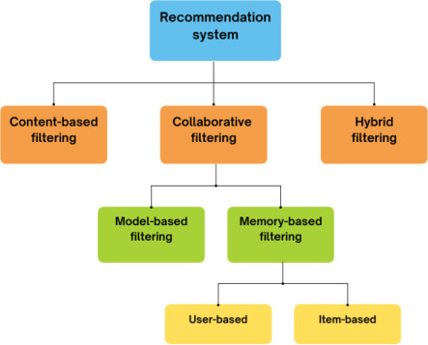

**Fig: Flow Chart Diagram of “Music Recommendation System”**

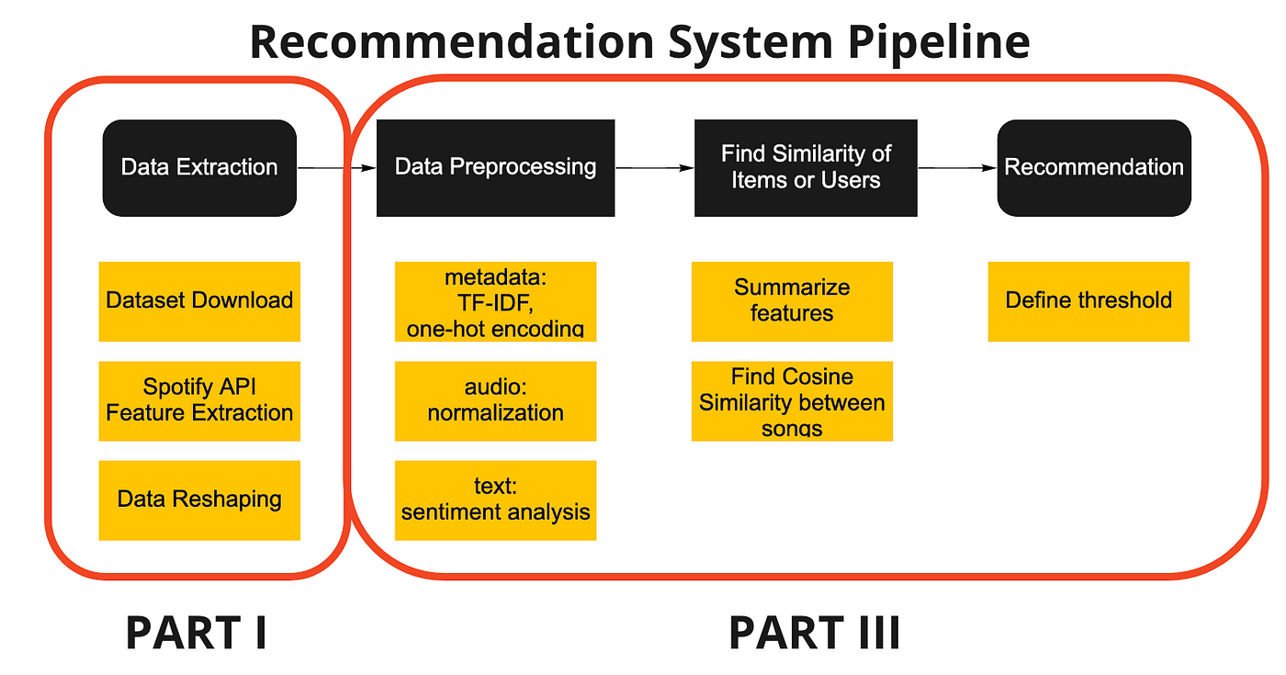

**Fig: Flow Chart Diagram of “Music Recommendation System”**

**4.7 Block Diagram (i).**

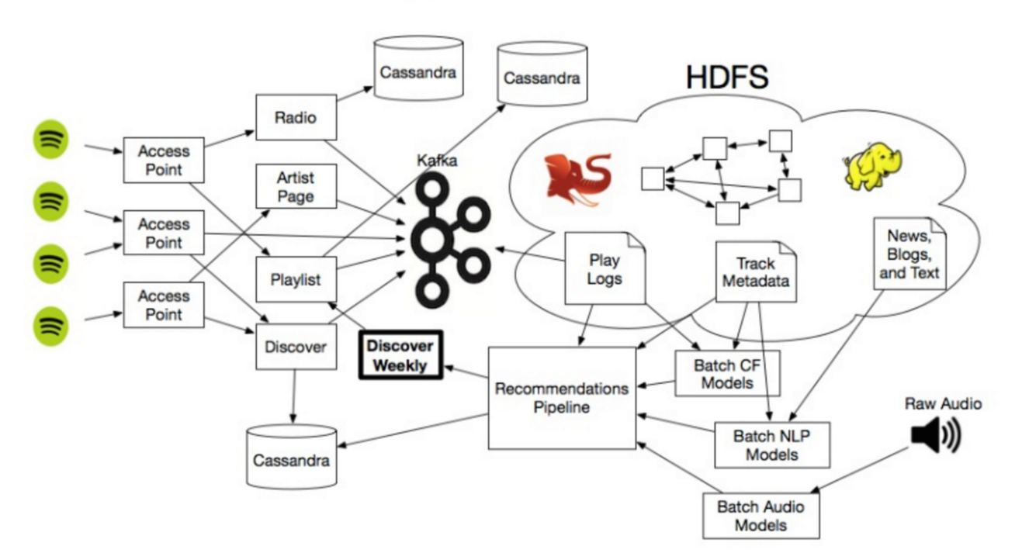

**Fig: Block Diagram of “Music Recommendation System by Spotify API”**

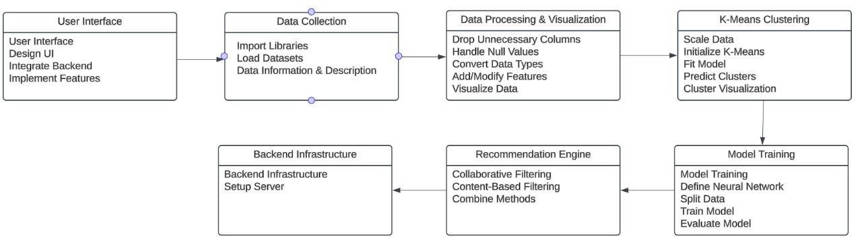

**Fig: Complete Flow of the Block Diagram in Short (Precise Form).**

**Explanation:**

Here's the block diagram explanation for the personalized music recommendation system project:

**(i). User Interface**

**User Interface Design:** The initial step involves designing an intuitive and user-friendly interface that allows users to interact with the recommendation system seamlessly.

**Integrate Backend:** Connecting the front end with the backend system to ensure smooth data flow and interaction.

**Implement Features:** Adding functionalities like song search, personalized recommendations, and user preferences.

**(ii). Data Collection**

**Import Libraries:** Utilizing necessary Python libraries such as pandas, NumPy, and others required for data manipulation and analysis.

**Load Datasets:** Fetching datasets from the Spotify API and other relevant sources.

**Data Information & Description:** Understanding the structure, types, and descriptions of the collected data.

**(iii). Data Processing & Visualization**

**Drop Unnecessary Columns:** Removing irrelevant columns from the dataset to streamline the analysis.

**Handle Null Values:** Addressing missing values through techniques like imputation or deletion.

**Convert Data Types:** Ensuring all data is in the correct format for analysis.

**Add/Modify Features:** Creating new features or modifying existing ones to improve the model’s performance.

**Visualize Data:** Using libraries like matplotlib, seaborn, and plotly to visualize the data and understand underlying patterns and relationships.

**(iv). K-Means Clustering**

**Scale Data:** Normalizing data to ensure consistent performance of the clustering algorithm.

**Initialize K-Means:** Setting up the K-Means clustering algorithm with an appropriate number of clusters.

**Fit Model:** Applying the K-Means algorithm to the dataset to identify clusters.

**Predict Clusters:** Assigning each data point to a cluster.

**Cluster Visualization:** Visualizing the clusters to understand the groupings of users or songs.

**(v). Model Training**

**Model Training:** Training machine learning models using the preprocessed data.

**Define Neural Network:** If using deep learning, defining the architecture of the neural network.

**Split Data:** Dividing the data into training and testing sets to evaluate model performance.

**Train Model:** Training the model using the training data.

**Evaluate Model:** Assessing the model's performance using metrics such as accuracy, precision, recall, and F1-score.

**(vi). Recommendation Engine**

**Collaborative Filtering:** Using user interaction data to predict preferences and recommend items.

**Content-Based Filtering:** Utilizing song metadata to find and recommend similar songs.

Combine Methods: Integrating both collaborative and content-based filtering approaches to form a hybrid recommendation system.

**(vii). Backend Infrastructure**

**Backend Infrastructure:** Setting up the necessary infrastructure to support the recommendation system.

**Setup Server:** Configuring servers to handle data processing, storage, and API requests.

1. **Results and Experimentations.**

* Now, we take the input from to a new user in order to Register.
* Once, User Successfully Register on the Platform.
* Then, it will ask the User’s Interests (Type of Song, Singer/Artists).
* Finally, it will Recommend on the Basis of ‘Popularity’

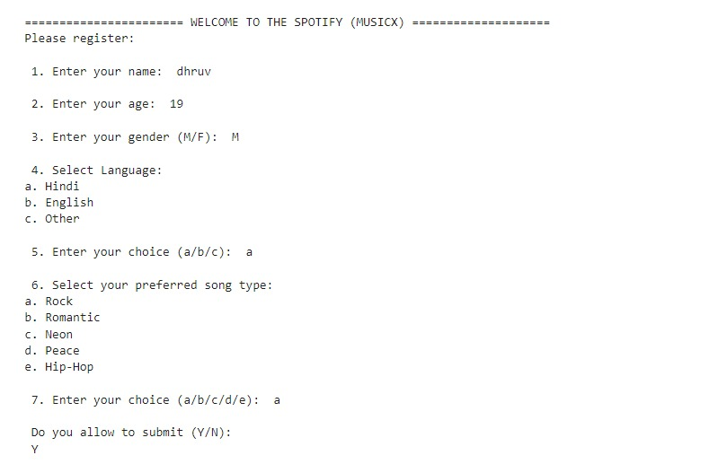

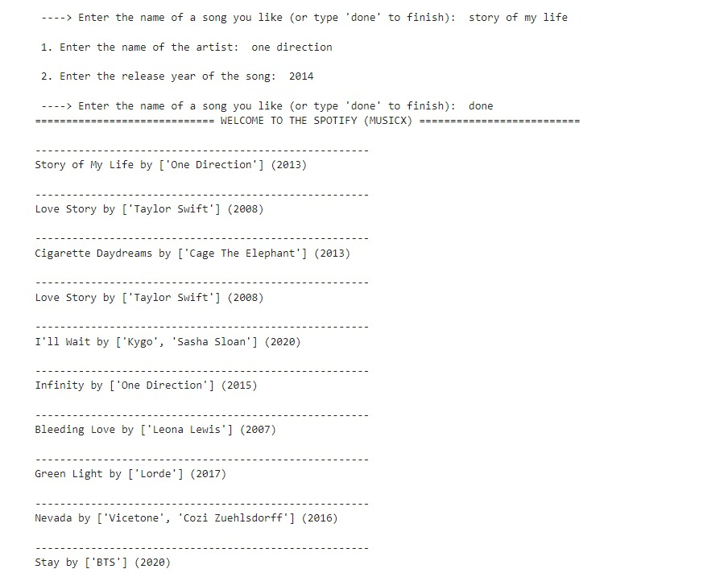

* We, also using the Stream-Lite Platform to build the “Music Recommendation System App” to represent our Dynamic Representation of the Program me in a real-world Implications.

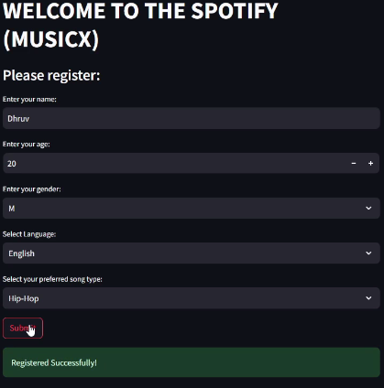

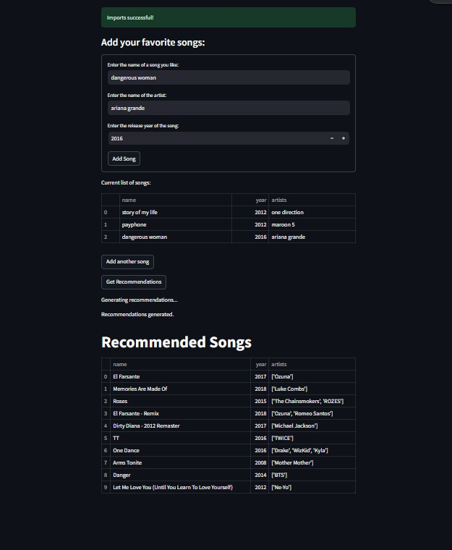

1. **Conclusions**

**Conclusions by Neural Nexus**

**1. Improved Accuracy:** The hybrid model developed by Neural Nexus significantly enhanced recommendation accuracy, resulting in better alignment with user preferences.

**2. Increased Satisfaction:** Users showed higher satisfaction and engagement with the new recommendations, reflecting a more enjoyable listening experience.

**3. Effective Personalization:** Detailed user profiles and music features contributed to highly personalized recommendations, making them more relevant to individual tastes.

**4. Successful Feedback Integration:** The feedback loop effectively refined the system, leading to continuous improvements based on user interactions.

**5. Future Challenges:** Scaling the system and addressing diverse user preferences remain key areas for future development.

1. **References**

**Kaggle:** [**https://www.kaggle.com/code/vatsalmavani/music-recommendation-system-using-spotify-dataset/notebook**](https://www.kaggle.com/code/vatsalmavani/music-recommendation-system-using-spotify-dataset/notebook)

**Google-Colab: https://colab.research.google.com/drive/1H9BA3PXAiPxkfV9ciVXlbjXlfpSffAVy**

**ChatGPT**

**Research Paper:** [**https://www.researchgate.net/publication/360624328_An_Exploratory_Study_on_the_Spotify_Recommender_System**](https://www.researchgate.net/publication/360624328_An_Exploratory_Study_on_the_Spotify_Recommender_System)

[**https://www.researchgate.net/publication/318511102_Recommender_System_Based_on_Collaborative_Filtering_for_Spotify's_Users**](https://www.researchgate.net/publication/318511102_Recommender_System_Based_on_Collaborative_Filtering_for_Spotify's_Users)

**Youtube-Reference:** [**https://youtu.be/gaZKjAKfe0s?si=U6fFL4R5Wd6GY0vZ**](https://youtu.be/gaZKjAKfe0s?si=U6fFL4R5Wd6GY0vZ)

**=================================================================**